Clarification on the doubted discrepancies:
Quick answer: There aren’t any mistakes in the analyses but the way the gathered data is interpreted for the summary results is a little different in the datasets which I will explain in detail the differences.
First, the dataset we used for the analysis and visualizations is “OntarioLead5_7_24.xlsx” attached below. This dataset has 3 sheets, “Master”, “Enrol” and “Pivot”. The “Master” sheet is something very similar to the “Data” sheet of your dataset. But there are tiny differences in these two sheets resulting in the discrepancy doubt which I will explain now.
There is a column named “Exceed2” in our dataset which is the corresponding column for the “Health Canada exceed (>5 ppb)” column in your dataset, but with a tiny difference, which is the check condition is not greater than 5, instead it is greater than or equal to 5. Based on this, as you can see one of the records for the “BAYSHORE PS” school which equals 5 is considered a federal failure in our given dataset but it isn’t a failure in your dataset, therefore your study shows 4 federal failures but ours shows 5 federal failures.
Our dataset, “Master” Sheet:

Your dataset, “Data” Sheet:
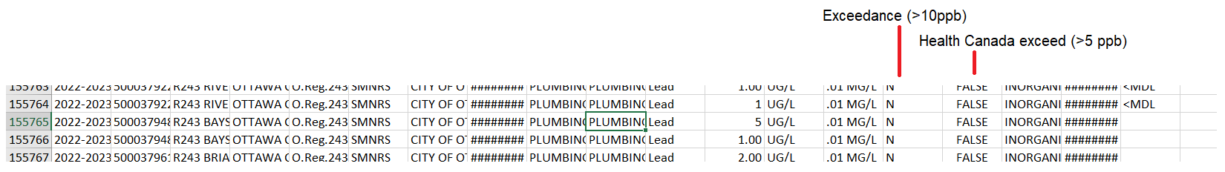

Note: The “Exceedance” column in our dataset is the exact corresponding column for the “Exceedance (>10ppb)” column in your dataset, I mean the check condition is greater than 10 in both of them and they are the same.

Our given dataset has another sheet named “Pivot” which aggregates the gathered data and as you can see the result for the “BAYSHORE PS” has 5 failures.
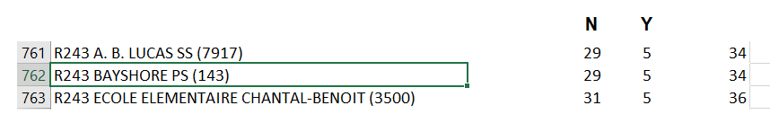
I hope the given comprehensive answer addresses doubted discrepancies clearly.

Bests,
AmirHosein Rostami

